
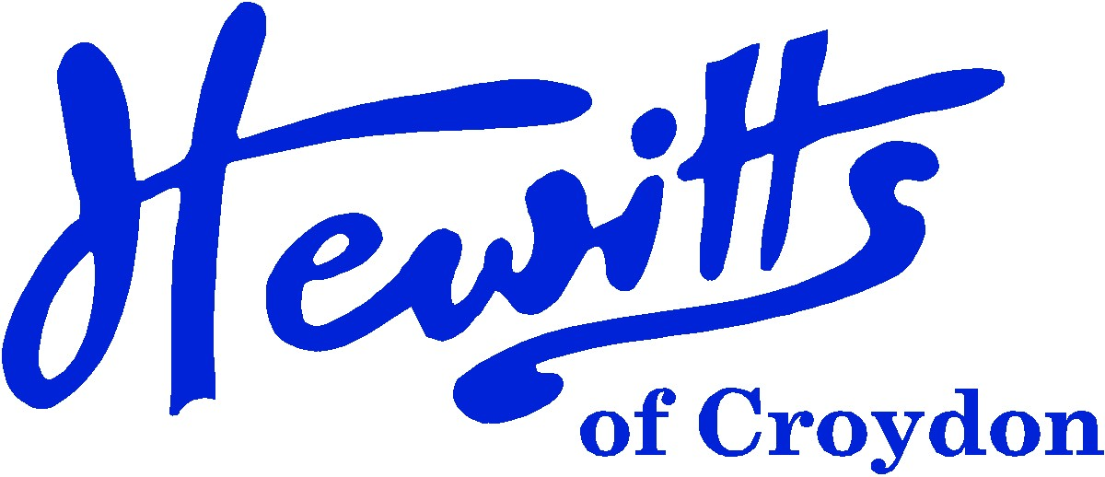

THE SMARTER CHOICE SINCE 1863

SCHOOL & SPORTSWEAR SPECIALISTS

Proud suppliers of
CASTLE HILL ACADEMY
SCHOOL UNIFORM PRICE GUIDE 2024

BOYS |  |  | GIRLS
Sweatshirt V-neck, Purple + logo | from | 13.50 | Sweatshirt V-neck, Purple + logo | from | 13.50
 |  |  | or Sweatcardy, Purple + logo | from | 14.00
or Pullover, Purple + logo | from | 19.50 | or Cardigan, Purple + logo | from | 20.00
Polo Shirt, White (Up to Year 5) | from | 6.00 | Polo Shirt, White (Up to Year 5) | from | 6.00
or Polo Shirt, White + logo (Up to Year 5) | . . . . | 9.00 | or Polo Shirt, White + logo (Up to Year 5) | . . . . | 9.00
Tie, Purple/White 45" (Year 6) | . . . . | 4.25 | Tie, Purple/White 45" (Year 6) | . . . . | 4.25
Shirt, White 2pk (Year 6) | from | 14.50 | Blouse, White BTN 2pk (Year 6) | from | 14.50
Trousers, Grey | from | 13.00 | Skirt, Grey | from | 8.50
 |  |  | or Trousers, Grey | . . . . | 16.00
Socks, Black, Charcoal or White Ankle 5pk | from | 5.75 | Socks, Black, Charcoal or White 5pk | from | 5.75
 |  |  | or Tights, Black or Charcoal 2pk | from | 7.50
Reversible Jkt, Purple (Opt) | from | 26.00 | Reversible Jkt, Purple (Opt) | from | 26.00
Fleece Jkt, Purple + logo (Opt) | . . . . | 16.00 | Fleece Jkt, Purple + logo (Opt) | . . . . | 16.00
Exp Bookbag, Purple + logo | . . . . | 9.00 | Exp Bookbag, Purple + logo | . . . . | 9.00
or Infant Backpack, Purple + logo (Opt) | . . . . | 13.75 | or Infant Backpack, Purple + logo (Opt) | . . . . | 13.75
or Junior Backpack, Purple + logo (Opt) | . . . . | 15.00 | or Junior Backpack, Purple + logo (Opt) | . . . . | 15.00
Shoes, Black with flat heel | from | 15.00 | Shoes, Black with flat heel | from | 15.00
SUMMER ALTERNATIVES |  |  | SUMMER ALTERNATIVES
Shorts, Grey | from | 11.00 | Summer Dress, Purple Gingham | . . . . | 16.50
SPORTS/PE |  |  | SPORTS/PE
T-shirt, White | from | 3.00 | T-shirt, White | from | 3.00
Jog Trousers, Black | from | 11.00 | Jog Trousers, Black | from | 11.00
PE Shorts, Black Attack | from | 6.00 | PE Shorts, Black Attack | from | 6.00
or PE Shorts, Black DL17 | from | 6.50 | or PE Shorts, Black DL17 | from | 6.50
Plimsolls, Black | from | 5.50 | Plimsolls, Black | from | 5.50
PE Bag, Purple | from | 4.75 | PE Bag, Purple | from | 4.75
or PE Bag, Purple + logo | . . . . | 8.00 | or PE Bag, Purple + logo | . . . . | 8.00

Hewitts of Croydon, 45 – 51 Church Street, Croydon, CR9 1QQ
T: 0208 688 1830 / 0208 680 4555 E: customercare@hewittsofcroydon.com W: www.hewittsofcroydon.com
This price list was accurate on 28/03/2024

CLICK & COLLECT | WWW.HEWITTSOFCROYDON.COM | COURIER DELIVERY
NAME TAPES | SCHOOLWEAR | SPORTSWEAR | WORKWEAR | SCOUTS & GUIDES
We only accept cash or Mastercard, Visa and Visa Debit
All prices stated are accurate at the time of printing. Whilst we endeavour to maintain our prices throughout the season, we cannot guarantee against price changes.

