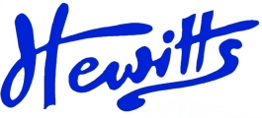
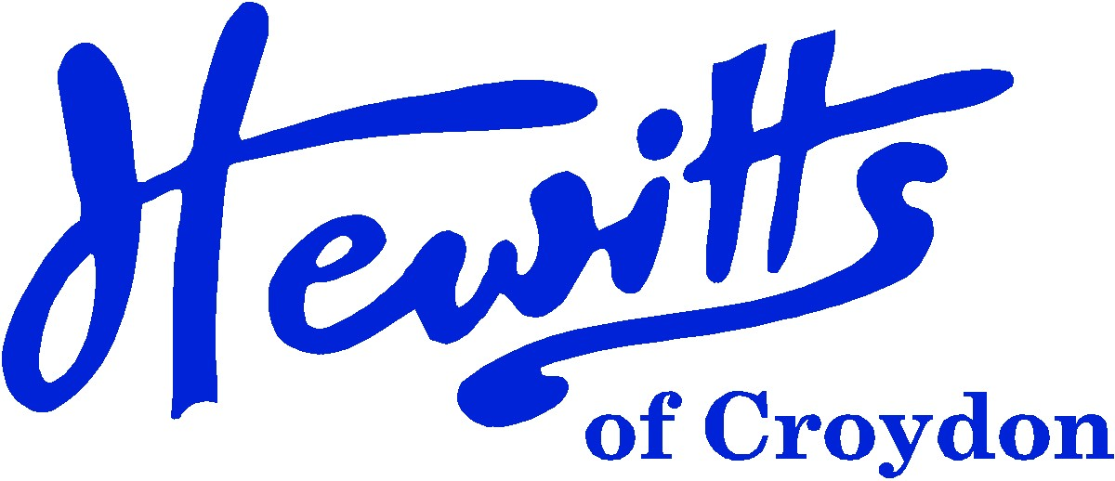

THE SMARTER CHOICE SINCE 1863

SCHOOL & SPORTSWEAR SPECIALISTS

Proud suppliers of
THE CRESCENT PRIMARY SCHOOL
KEY STAGE 2
SCHOOL UNIFORM PRICE GUIDE 2024

BOYS |  |  | GIRLS
Pullover, Purple + logo | from | 19.50 | Pullover, Purple + logo | from | 19.50
or Cardigan, Purple + logo | from | 20.00 | or Cardigan, Purple + logo | from | 20.00
Tie, Violet/White Elastic (New 2023) | . . . . | 3.50 | Tie, Violet/White Elastic (New 2023) | . . . . | 3.50
or Tie, Violet/White 45” | . . . . | 4.00 | or Tie, Violet/White 45” | . . . . | 4.00
Shirt, White S/S 2pk | from | 14.50 | Blouse, White BTN S/S 2pk | from | 14.50
Trousers, Grey | from | 13.00 | Skirt, Grey | from | 8.50
 |  |  | or Trousers, Grey | . . . . | 16.00
Socks, Grey or White 5pk | from | 5.75 | Socks, Grey or White 5pk | from | 5.75
 |  |  | or Tights, Grey 2pk | from | 7.50
*Reversible Jkt, Purple + logo | . . . . | 28.00 | *Reversible Jkt, Purple + logo | . . . . | 28.00
*Fleece Jkt, Purple + logo | from | 16.00 | *Fleece Jkt, Purple + logo | from | 16.00
*Ski Hat, Purple + logo | . . . . | 7.50 | *Ski Hat, Purple + logo | . . . . | 7.50
Inf Backpack, Purple + logo | . . . . | 13.75 | Inf Backpack, Purple + logo | . . . . | 13.75
or Jnr Backpack, Purple + logo | . . . . | 15.00 | or Jnr Backpack, Purple + logo | . . . . | 15.00
Shoes, Black | from | 15.00 | Shoes, Black | from | 15.00
NO TRAINERS, BOOTS OR SHOES THAT HAVE PICTURES, FLASHING LIGHTS OR WHITE SOLES
SUMMER ALTERNATIVES |  |  | SUMMER ALTERNATIVES
Shorts, Grey | from | 11.00 | *Summer Dress, Purple Gingham | . . . . | 16.50
*Legionnaire Cap, Purple + logo | . . . . | 5.75 | *Legionnaire Cap, Purple + logo | . . . . | 5.75
SPORTS/PE |  |  | SPORTS/PE
T-shirt, Purple + logo | from | 6.00 | T-shirt, Purple + logo | from | 6.00
PE Shorts, Black Attack | from | 6.00 | PE Shorts, Black Attack | from | 6.00
Plimsolls, Black or plain trainers | from | 5.00 | Plimsolls, Black or plain trainers | from | 5.00
PE Bag, Purple + logo | . . . . | 8.00 | PE Bag, Purple + logo | . . . . | 8.00
Sweatshirt, Black (outdoor) | from | 9.50 | Sweatshirt, Black (outdoor) | from | 9.50
Jog Trousers, Black or Grey (outdoor) | from | 11.00 | Jog Trousers, Black or Grey (outdoor) | from | 11.00
* These items of the Uniform are OPTIONAL

CLICK & COLLECT | WWW.HEWITTSOFCROYDON.COM | COURIER DELIVERY
NAME TAPES | SCHOOLWEAR | SPORTSWEAR | WORKWEAR | SCOUTS & GUIDES
We only accept cash or Mastercard, Visa and Visa Debit
All prices stated are accurate at the time of printing. Whilst we endeavour to maintain our prices throughout the season, we cannot guarantee against price changes.

