
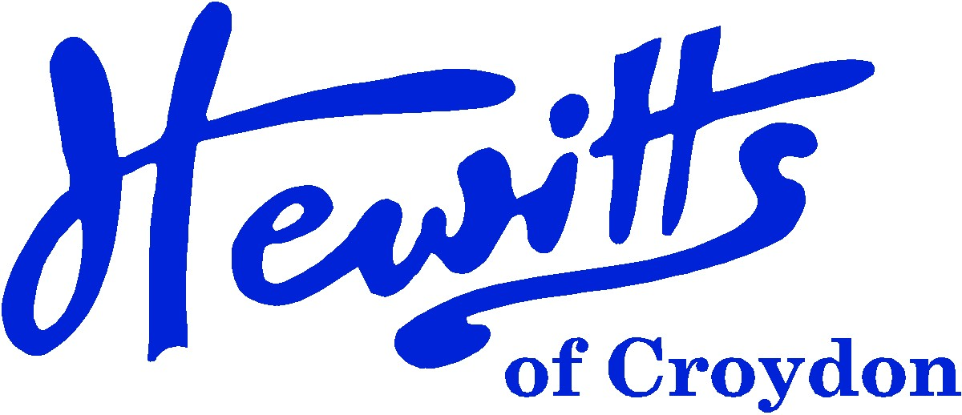

THE SMARTER CHOICE SINCE 1863

SCHOOL & SPORTSWEAR SPECIALISTS

Proud suppliers of

ELMWOOD JUNIOR SCHOOL

SCHOOL UNIFORM PRICE GUIDE 2024

BOYS |  |  | GIRLS
Sweatshirt, Navy + logo | from | 12.00 | Sweatshirt, Navy + logo | from | 12.00
 |  |  | or Sweatcardy, Navy + logo | from | 14.00
Shirt, White 2pk | from | 14.50 | Blouse, White BTN 2pk | from | 14.50
Tie, Elmwood 39” | . . . . | 4.00 | Tie, Elmwood 39” | . . . . | 4.00
Trousers, Grey, Charcoal or Black | from | 13.00 | Skirt, Grey or Black | from | 8.50
 |  |  | or Tunic, Grey or Black (BLACK NOT STOCKED) | from | 17.50
 |  |  | or Trousers, Grey or Black | . . . . | 16.00
 |  |  | Tights, White, Navy or Black | from | 7.50
Socks, Grey, Charcoal or Black 5pk | from | 5.75 | or Socks, White, Navy or Black 5pk | from | 5.75
Waterproof Jkt, Navy | from | 13.00 | Waterproof Jkt, Navy | from | 13.00
Bookbag, Navy + logo | from SCHOOL |  | Bookbag, Navy + logo | from SCHOOL
Shoes, Black | from | 15.00 | Shoes, Black | from | 15.00
SUMMER ALTERNATIVES |  |  | SUMMER ALTERNATIVES
Shorts, Grey | from | 11.00 | Summer Dress, Blue Gingham | . . . . | 16.50
Polo Shirt, Yellow or White | from | 6.00 | or Polo Shirt, Yellow or White | from | 6.00
SPORTS/PE |  |  | SPORTS/PE
PE Shorts, Navy DL17 | from | 6.50 | PE Shorts, Navy DL17 | from | 6.50
T-shirt, Yellow + printed logo | from | 5.50 | T-shirt, Yellow + printed logo | from | 5.50
or T-shirt, Yellow | from | 3.50 | or T-shirt, Yellow | from | 3.50
Sweatshirt, Navy (Outdoor) | from | 9.50 | Sweatshirt, Navy (Outdoor) | from | 9.50
Jog Trousers, Navy (Outdoor) | from | 11.00 | Jog Trousers, Navy (Outdoor) | from | 11.00
PE Bag, Navy + logo | . . . . | 6.00 | PE Bag, Navy + logo | . . . . | 6.00
Plimsolls, Black (Indoor) | from | 5.00 | Plimsolls, Black (Indoor) | from | 5.00
or Trainers, Black | from | 20.00 | or Trainers, Black | from | 20.00
NB: NAME LABELS ARE REQUIRED ON ALL CLOTHING

Hewitts of Croydon, 45 – 51 Church Street, Croydon, CR9 1QQ
T: 0208 688 1830 / 0208 680 4555 E: customercare@hewittsofcroydon.com W: www.hewittsofcroydon.com
This price list was accurate on 04/04/2024
CLICK & COLLECT | WWW.HEWITTSOFCROYDON.COM | COURIER DELIVERY
NAME TAPES | SCHOOLWEAR | SPORTSWEAR | WORKWEAR | SCOUTS & GUIDES
We only accept cash or Mastercard, Visa and Visa Debit
All prices stated are accurate at the time of printing. Whilst we endeavour to maintain our prices throughout the season, we cannot guarantee against price changes.

