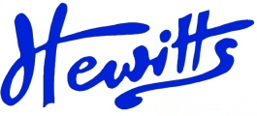
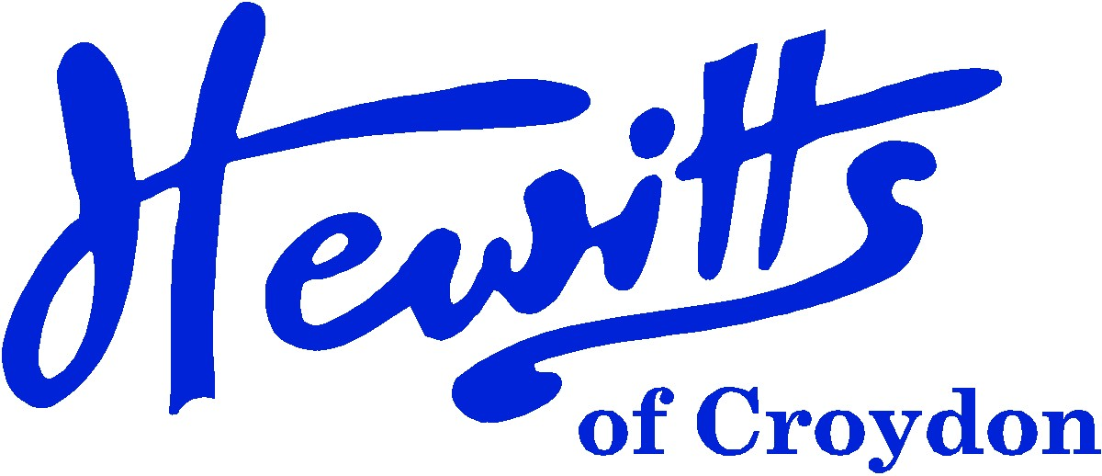

THE SMARTER CHOICE SINCE 1863

SCHOOL & SPORTSWEAR SPECIALISTS

Proud suppliers of
GOOD SHEPHERD CATHOLIC
PRIMARY & NURSERY SCHOOL
SCHOOL UNIFORM PRICE GUIDE 2024
BOYS |  |  | GIRLS
NURSERY |  |  | NURSERY
Sweatshirt, Red + logo | from | 12.00 | Sweatshirt, Red + logo | from | 12.00
Jog Trousers, Navy | from | 11.00 | Jog Trousers, Navy | from | 11.00
T-shirt, Red + logo | from | 5.50 | T-shirt, Red + logo | from | 5.50
Coat, Dark colour | from | 26.00 | Coat, Dark colour | from | 26.00
Socks, Grey or White Ankle | from | 5.75 | Socks, Grey or White Ankle | from | 5.75
PE Shorts, Navy DL17 (Summer) | from | 6.50 | PE Shorts, Navy DL17 (Summer) | from | 6.50
Baseball Cap, Red | . . . . | 3.25 | Baseball Cap, Red | . . . . | 3.25
Bookbag, Red + logo | . . . . | 8.00 | Bookbag, Red + logo | . . . . | 8.00
Shoes, Black (no trainers or boots) | from | 15.00 | Shoes, Black (no trainers or boots) | from | 15.00
RECEPTION - YEAR 6 (Can Be Worn All Year) |  |  | RECEPTION - YEAR 6 (Can Be Worn All Year)
Pullover, Grey/Red Stripe | from | 19.00 | Pullover, Grey/Red Stripe | from | 19.00
 |  |  | or Cardigan, Grey/Red Stripe | from | 21.00
Tie, Red/White Clip on (Yrs 3 - 6) | . . . . | 5.00 | Tie, Red/White Clip on (Yrs 3 - 6) | . . . . | 5.00
or Tie, Red/White 39" (Yrs 3 - 6) | . . . . | 4.00 | or Tie, Red/White 39" (Yrs 3 - 6) | . . . . | 4.00
Polo Shirt, White (Rec – Yr 2) | from | 6.00 | Polo Shirt, White (Rec – Yr 2) | from | 6.00
Shirt, White 2pk (Yrs 3 - 6) | from | 14.50 | Blouse, White BTN 2pk (Yrs 3 - 6) | from | 14.50
 |  |  | Skirt/Tunic Grey | from | 8.50
Trousers, Grey | from | 13.00 | or Trousers, Grey | . . . . | 16.00
Socks, Grey Ankle 5pk | from | 5.75 | Socks, White Ankle 5pk | from | 5.75
 |  |  | or Tights, Grey 2pk | from | 7.50
Coat, Dark colour | from | 26.00 | Coat, Dark colour | from | 26.00
Bookbag, Red + logo (Recep) | . . . . | 8.00 | Bookbag, Red + logo (Recep) | . . . . | 8.00
Inf Backpack, Red + logo (Yrs 1-6) | . . . . | 13.50 | Inf Backpack, Red + logo (Yrs 1-6) | . . . . | 13.50
or Jnr Backpack, Red + logo (Yrs 1-6) | . . . . | 15.00 | or Jnr Backpack, Red + logo (Yrs 1-6) |  | 15.00
Shoes, Black (no trainers or boots) | from | 15.00 | Shoes, Black (no trainers or boots) | from | 15.00
SUMMER ALTERNATIVES (Can Be Worn All Year) |  |  | SUMMER ALTERNATIVES (Can Be Worn All Year)
Shorts, Grey | from | 11.00 | Summer Dress, Red Gingham | . . . . | 16.50
Baseball Cap, Red | . . . . | 3.15 | Baseball Cap, Red | . . . . | 3.15
SPORTS/PE |  |  | SPORTS/PE
Sweatshirt, Navy | from | 9.50 | Sweatshirt, Navy | from | 9.50
T-shirt, Red + logo | from | 5.50 | T-shirt, Red + logo | from | 5.50
PE Shorts, Navy | from | 6.00 | PE Shorts, Navy | from | 6.00
Jog Trousers, Navy | from | 11.00 | Jog Trousers, Navy | from | 11.00
PE Bag, Red | from | 3.50 | PE Bag, Red | from | 3.50
Trainers any or Plimsolls, Black | from | 5.00 | Trainers any or Plimsolls, Black | from | 5.00
Swim Trunks, Dark colour (Yrs 3-6) | from | 16.00 | Swimsuit, Dark colour (Yrs 3-6) | from | 17.50

CLICK & COLLECT | WWW.HEWITTSOFCROYDON.COM | COURIER DELIVERY
NAME TAPES | SCHOOLWEAR | SPORTSWEAR | WORKWEAR | SCOUTS & GUIDES
We only accept cash or Mastercard, Visa and Visa Debit
All prices stated are accurate at the time of printing. Whilst we endeavour to maintain our prices throughout the season, we cannot guarantee against price changes.

