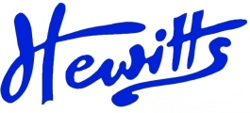
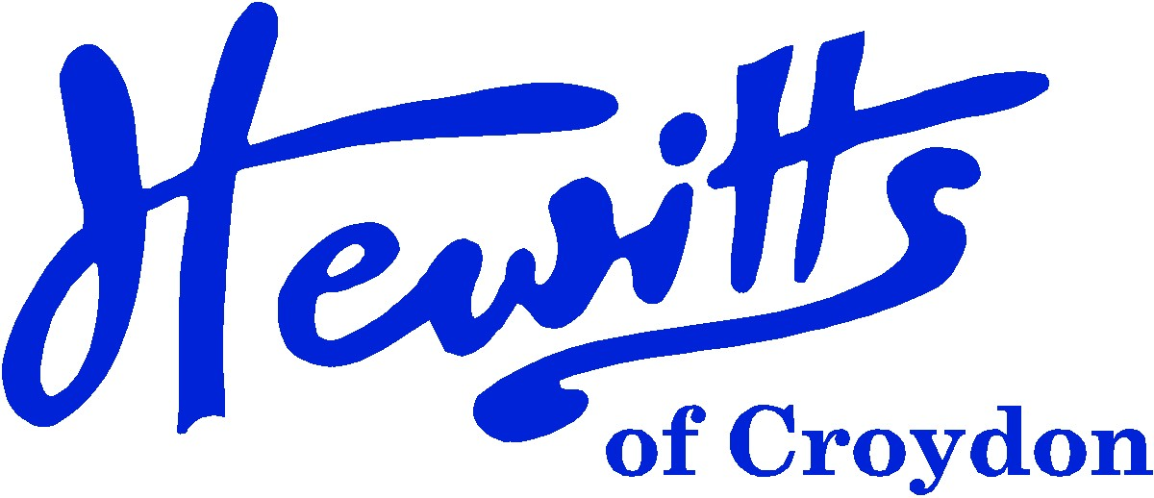
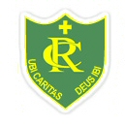
THE SMARTER CHOICE SINCE 1863

SCHOOL & SPORTSWEAR SPECIALISTS

Proud suppliers of
REGINA COELI RC PRIMARY SCHOOL
SCHOOL UNIFORM PRICE GUIDE 2024

BOYS |  |  | GIRLS
Pullover, Bottle + logo | from | 18.00 | Pullover, Bottle + logo (KS1 & 2) | from | 18.00
PLAIN PULLOVERS AND CARDIGANS CAN BE WORN |  |  | or Cardigan, Bottle + logo | from | 19.00
Polo Shirt, White + logo (Reception Only) | . . . . | 8.00 | Polo Shirt, White + logo (Reception Only) | . . . . | 8.00
or Polo Shirt, White (Reception Only) | . . . . | 6.00 | or Polo Shirt, White (Reception Only) | . . . . | 6.00
Tie, O/Elastic (KS1) | . . . . | 3.50 | Tie, O/Elastic (KS1) | . . . . | 3.50
Tie, 39” (KS2) | . . . . | 4.00 | Tie, 39” (KS2) | . . . . | 4.00
Shirt, White 2pk (KS1 & KS2) | from | 14.00 | Blouse, White BTN 2pk (KS1 & KS2) | from | 14.00
Trousers, Grey | from | 12.50 | Skirt, Brown | from | 8.50
or Shorts, Grey | from | 10.50 | or Tunic, Brown | from | 16.50
 |  |  | Tights, Brown (not stocked) or Bottle 2pk | from | 7.50
Socks, Grey or Charcoal Ankle 5pk | from | 5.75 | or Socks, Brown | NOT STOCKED
Scarf, Hat & Gloves, Bottle or Brown | from | 3.25 | Scarf, Hat & Gloves, Bottle or Brown | from | 3.25
Reversible Jkt, Bottle + logo | from | 28.00 | Reversible Jkt, Bottle + logo | from | 28.00
PLAIN BROWN, GREEN OR BLACK COATS ARE ALLOWED.
Bookbag, Bottle + logo (EYFS & KS1) | . . . . | 7.50 | Bookbag, Bottle + logo (EYFS & KS1) | . . . . | 7.50
Junior Backpack, Bottle + logo (KS2 Only) | . . . . | 14.50 | Junior Backpack, Bottle + logo (KS2 Only) | . . . . | 14.50
Shoes, Black | from | 15.00 | Shoes, Black | from | 15.00
SUMMER ALTERNATIVES |  |  | SUMMER ALTERNATIVES
Polo Shirt, White | from | 6.00 | Summer Dress, Green Gingham | . . . . | 16.50
 |  |  | Socks, White Ankle 5pk | from | 5.75
SPORTS/PE |  |  | SPORTS/PE
T-shirt, Yellow + Logo + REGINA COELI | from | 7.50 | T-shirt, Yellow + Logo + REGINA COELI | from | 7.50
PE Shorts, Bottle DL17 | from | 6.50 | PE Shorts, Bottle DL17 | from | 6.50
Sports Socks, White 2pk or 3pk | from | 4.50 | Sports Socks, White 2pk or 3pk | from | 4.50
Fleece Jkt, Bottle + logo | . . . . | 15.00 | Fleece Jkt, Bottle + logo | . . . . | 15.00
Jog Trs, Black or Any Shade of Green | from | 11.00 | Jog Trs, Black or Any Shade of Green | from | 11.00
Plimsolls, Black (KS1) | from | 5.00 | Plimsolls, Black (KS1) | from | 5.00
Trainers, any (KS2) | from | 20.00 | Trainers, any (KS2) | from | 20.00
Swim Trunks, Dark coloured (KS2) | from | 16.00 | Swimsuit, Dark coloured (KS2) | from | 17.50
Swim Cap, any (KS2 Compulsory) | from | 6.00 | Swim Cap, any (KS2 Compulsory) | from | 6.00

Hewitts of Croydon, 45 – 51 Church Street, Croydon, CR9 1QQ
T: 0208 688 1830 / 0208 680 4555 E: customercare@hewittsofcroydon.com W: www.hewittsofcroydon.com
This price list was accurate on 26/04/2024

CLICK & COLLECT | WWW.HEWITTSOFCROYDON.COM | COURIER DELIVERY
NAME TAPES | SCHOOLWEAR | SPORTSWEAR | WORKWEAR | SCOUTS & GUIDES
We only accept cash or Mastercard, Visa and Visa Debit
All prices stated are accurate at the time of printing. Whilst we endeavour to maintain our prices throughout the season, we cannot guarantee against price changes.

