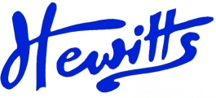
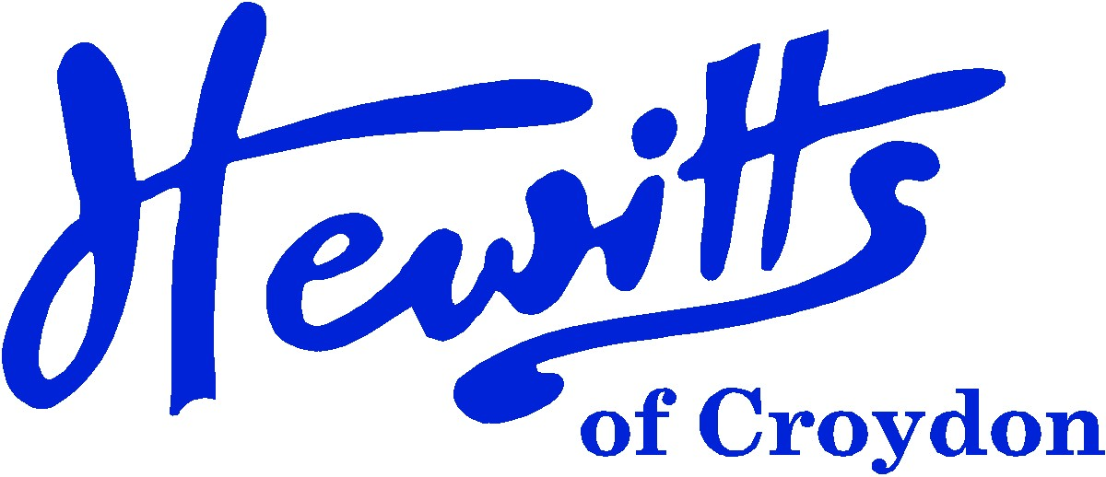
THE SMARTER CHOICE SINCE 1863

SCHOOL & SPORTSWEAR SPECIALISTS

Proud suppliers of
THE ROBERT FITZROY ACADEMY

Direct to Parent – Online Only

SCHOOL UNIFORM PRICE GUIDE 2024

BOYS |  |  | GIRLS
$ Blazer, Navy Badged (Yrs 5 & 6 Only) | from | 28.00 | $ Blazer, Navy Badged (Yrs 5 & 6 Only) | from | 28.00
$ Tie, Navy/Gold stripe elastic(Yrs 1 - 2) | . . . . | 3.50 | $ Tie, Navy/Gold stripe elastic (Yrs 1-2) | . . . . | 3.50
$ Tie, Navy/Gold stripe 45” (Yrs 3 - 6) | .... | 4.00 | $ Tie, Navy/Gold stripe 45” (Yrs 3 - 6 Only) | .... | 4.00
# Pullover P25, Navy + logo | from | 12.00 | # Pullover P25, Navy + logo | from | 12.00
 |  |  | or # Cardigan P25, Navy + logo | from | 13.00
# Polo Shirt, Navy + logo (Recep Only) | .... | 6.50 | # Polo Shirt, Navy + logo (Reception Only) | .... | 6.50
* Shirt, White BTN (Yrs 1 - 6 Only) | from | 12.00 | * Blouse, White BTN (Yrs 1 - 6 Only) | from | 12.00
* Trousers Jnr, Grey DL944 | .... | 11.00 | * Skirt, Grey DL974 | from | 12.00
* or Shorts, Grey | from | 11.00 | *or Trousers Jnr, Grey DL970 (Only) | from | 12.00
 |  |  | *or Tunic/Pinafore, Grey | from | 13.00
 |  |  | * Summer Dress, Navy Gingham (Summer) | from | 16.50
* Socks, Grey Ankle 5pk | from | 4.25 | * Socks or Tights, Grey Ankle 5pk | from | 4.25
$ Bookbag, Navy/Gold + logo (New 24) | .... | 7.50 | $ Bookbag, Navy/Gold + logo (New 2024) | .... | 7.50
$ Junior Backpack, Navy + logo | .... | 12.00 | $ Junior Backpack, Navy + logo | .... | 12.00
$ Fleece Jacket, Navy + logo | . . . . | 13.50 | $ Fleece Jacket, Navy + logo | . . . . | 13.50
$ Baseball Cap, Navy + logo (Summer) | .... | 6.00 | $ Baseball Cap, Navy + logo) (Summer) | .... | 6.00
$ Legionnaire Cap, Navy + logo | .... | 6.50 | $ Legionnaire Cap, Navy + logo | .... | 6.50
$ Ski Hat, Navy + logo (Winter) | .... | 6.00 | $ Ski Hat, Navy + logo (Winter) | .... | 6.00
* Shoes, Black | from | 15.00 | * Shoes, Black | from | 15.00
SPORTS/PE |  |  | SPORTS/PE
# T-Shirt, White + House Colour logos | from | 5.50 | # T-Shirt, White + House Colour logos | from | 5.50
$ PE Shorts, Navy Attack + logo | from | 6.50 | $ PE Shorts, Navy Attack + logo | from | 6.50
 |  |  | or $ Games Skort, Navy + logo | from | 12.00
$ Jog Trousers, Navy + logo | from | 10.50 | $ Jog Trousers, Navy + logo | from | 10.50
$ Sweatshirt, Navy + logo | from | 9.50 | $ Sweatshirt, Navy + logo | from | 9.50
$ Hoody, Navy + logo | from | 12.00 | $ Hoody, Navy + logo | from | 12.00
* Sports Socks, White 2pk or 3pk | from | 3.50 | * Sports Socks, White 2pk or 3pk | from | 3.50
$ Drawstring bag, Navy RS22 + logo | . . . . | 6.00 | $ Drawstring bag, Navy RS22 + logo | . . . . | 6.00
House Colours: BEAGLE = Red, GANGES = Yellow, GLENDOWER = Emerald Green, THETIS = Royal Blue
# = COMPULSORY items that can only be purchased at Hewitts
$ = OPTIONAL items that can only be purchased at Hewitts
*= Items can be purchased from Hewitts or elsewhere

Hewitts of Croydon, 45 – 51 Church Street, Croydon, CR9 1QQ
T: 0208 688 1830 / 0208 680 4555 E: customercare@hewittsofcroydon.com W: www.hewittsofcroydon.com
This price list was accurate on 23/05/2024.

DIRECT TO PARENTS | WWW.HEWITTSOFCROYDON.COM | COURIER DELIVERY
NAME TAPES | SCHOOLWEAR | SPORTSWEAR | WORKWEAR | SCOUTS & GUIDES
We only accept Mastercard, Visa and Visa Debit
All prices stated are accurate at the time of printing. Whilst we endeavour to maintain our prices throughout the season, we cannot guarantee against price changes.
Hewitts will be selling at RFA on:
Monday 1st July 2024 between 10am – 12.30pm
We will have stock of the full uniform.

