
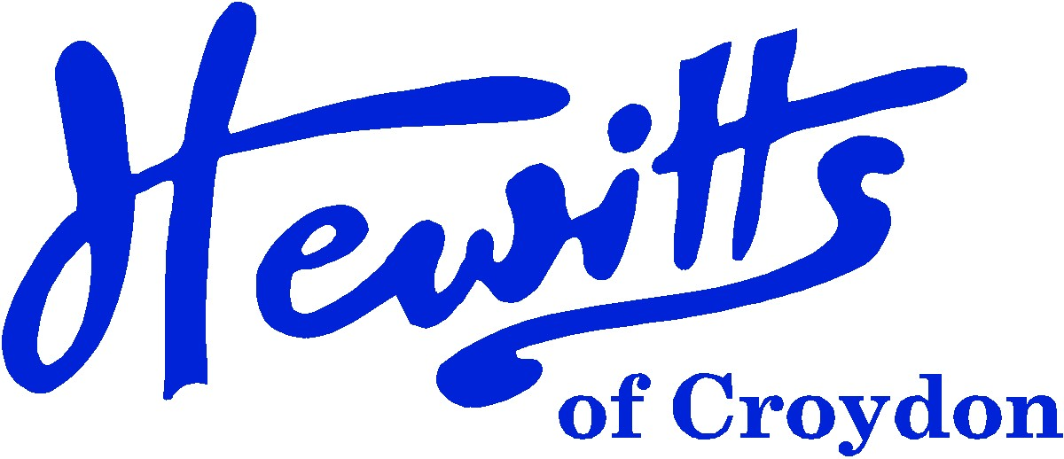

THE SMARTER CHOICE SINCE 1863

SCHOOL & SPORTSWEAR SPECIALISTS

Proud suppliers of
WINTERBOURNE JUNIOR GIRLS
YEARS 3 – 6
SCHOOL UNIFORM PRICE GUIDE 2024

Blazer, Black Badged | from | 34.00
Tie, 39” ONLY | . . . . | 4.00
Pullover, Red + logo | from | 19.00
or Cardigan, Red + logo | from | 19.50
Skirt, Black | from | 8.50
or Tunic, Black | NOT STOCKED
or Trousers, Black | . . . . | 16.00
Blouse, White BTN 2pk | from | 14.50
Socks, Black or White 5pk | from | 5.75
or Tights, Black, White or Red 2pk | from | 7.50
Coat or Reversible Jacket, Black or Red any style | from | 26.00
Document Case DCO1, Red + logo | . . . . | 12.00
or Junior Backpack JBMP12, Red + logo | . . . . | 15.00
Shoes, Black | from | 15.00
SUMMER ALTERNATIVES
Summer Dress, Red Gingham | . . . . | 16.50
SPORTS/PE
Polo Shirt, Red + logo | from | 9.00
PE Shorts, Black | from | 6.50
Sweatshirt, Black + logo | from | 12.00
Jog Trousers, Black | from | 11.00
Swimsuit, Black | from | 17.50
Swimbag, Red + logo | . . . . | 7.50
Trainers, Black | from | 20.00

Hewitts of Croydon, 45 – 51 Church Street, Croydon, CR9 1QQ
T: 0208 688 1830 / 0208 680 4555 E: customercare@hewittsofcroydon.com W: www.hewittsofcroydon.com
This price list was accurate on 27/04/2024
CLICK & COLLECT | WWW.HEWITTSOFCROYDON.COM | COURIER DELIVERY
NAME TAPES | SCHOOLWEAR | SPORTSWEAR | WORKWEAR | SCOUTS & GUIDES
We only accept cash or Mastercard, Visa and Visa Debit
All prices stated are accurate at the time of printing. Whilst we endeavour to maintain our prices throughout the season, we cannot guarantee against price changes.

